Experiment No: 06

Experiment Name: Student Information System (SIS)

1. Introduction
Student Information System (SIS) is a software system used to manage student-related information such as student profiles, academic results processing, GPA calculation, and teacher evaluation.
In traditional systems, student records and result processing are handled manually, which often leads to errors, data inconsistency, and delays. This system automates the process to ensure data integrity, accuracy, and efficiency.
The main focus of this system is maintaining accurate student data and reliable GPA calculation, along with proper evaluation of teachers.

2. Objectives
- To automate student information management
- To maintain student profiles efficiently
- To process exam results accurately
- To calculate GPA automatically
- To manage teacher evaluation system
- To ensure data integrity and consistency

3. Functional Requirements
The system should be able to:
- Register new students
- Allow student login and profile management
- Store and update student academic records
- Input and process exam results
- Calculate GPA automatically
- Generate grade reports
- Allow teachers to submit marks
- Evaluate teachers based on student feedback
- Maintain history of student performance
- Generate reports for administration

4. Non-Functional Requirements
The system should:
- Provide fast and efficient performance
- Ensure data integrity and accuracy
- Be secure and protect sensitive data
- Be user-friendly and easy to use
- Support backup and recovery
- Be reliable and scalable

5. Use Case Modeling

Actors:
- Student
- Teacher
- Admin

Main Use Cases:
- Register Student
- Login
- Manage Profile
- Submit Marks
- Calculate GPA
- View Result
- Evaluate Teacher
- Generate Report

Use Case Diagram:
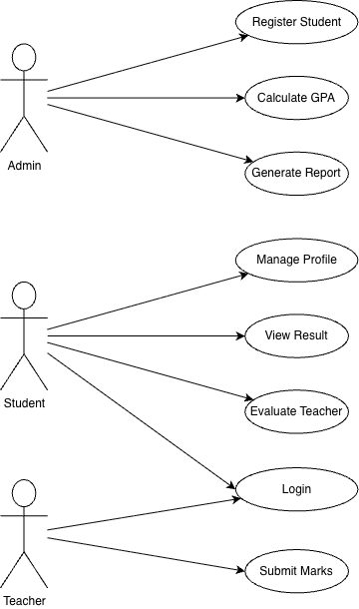

6. Structural Design (Class Diagram)

Main Classes:
- User
- Student
- Teacher
- Course
- Result
- GPA
- Evaluation

Description:
- User is the parent class
- Student and Teacher inherit from User
- Student enrolls in courses
- Teacher teaches courses and submits marks
- Result stores marks and grades
- GPA calculates student performance
- Evaluation stores teacher ratings

Attributes and Methods
User
- Attributes: id, name
- Method: login()
Student
- Method: viewResult(), giveEvaluation()
Teacher
- Method: submitMarks()
Course
- Attributes: course_id, course_name
Result
- Attributes: marks, grade
GPA
- Method: calculateGPA()
Evaluation
- Attribute: rating

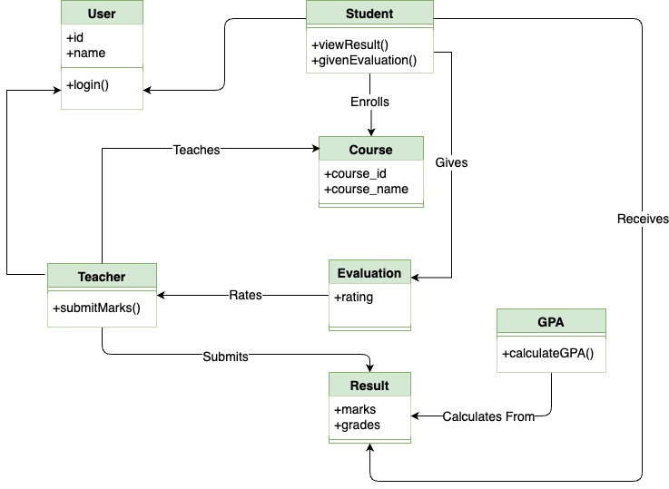

7. Database Design (ER Diagram)

7.1 Entities
- Student
- Teacher
- Course
- Result
- Evaluation

7.2 Relationships
- Student enrolls in Course
- Teacher teaches Course
- Teacher submits Result
- Student receives Result
- Student gives Evaluation to Teacher

7.3 Suggested Primary Keys and Foreign Keys
STUDENT
- student_id (PK)
- name
- department
TEACHER
- teacher_id (PK)
- name
- department
COURSE
- course_id (PK)
- course_name
RESULT
- result_id (PK)
- student_id (FK)
- course_id (FK)
- marks
- grade
EVALUATION
- evaluation_id (PK)
- student_id (FK)
- teacher_id (FK)
- rating

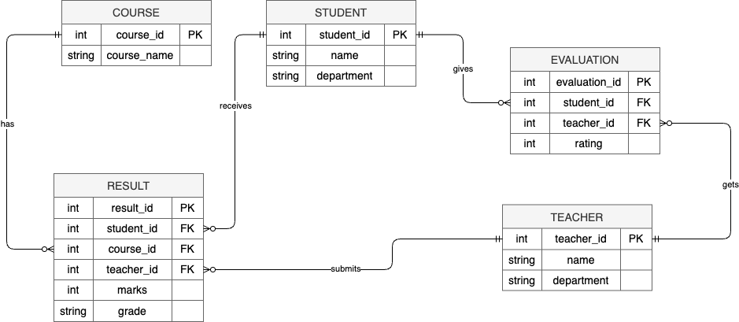

8. Advantages
- Reduces manual errors
- Ensures accurate GPA calculation
- Maintains data integrity
- Saves time and effort
- Easy access to student information
- Improves decision-making

9. Limitations
- Requires technical knowledge
- Initial setup cost is high
- System failure may affect operations
- Needs proper security measures

10. Conclusion
The Student Information System (SIS) is an effective solution for managing student data digitally. It ensures accurate result processing, reliable GPA calculation, and proper teacher evaluation. The system improves efficiency, reduces errors, and maintains strong data integrity, making it essential for modern educational institutions.

